




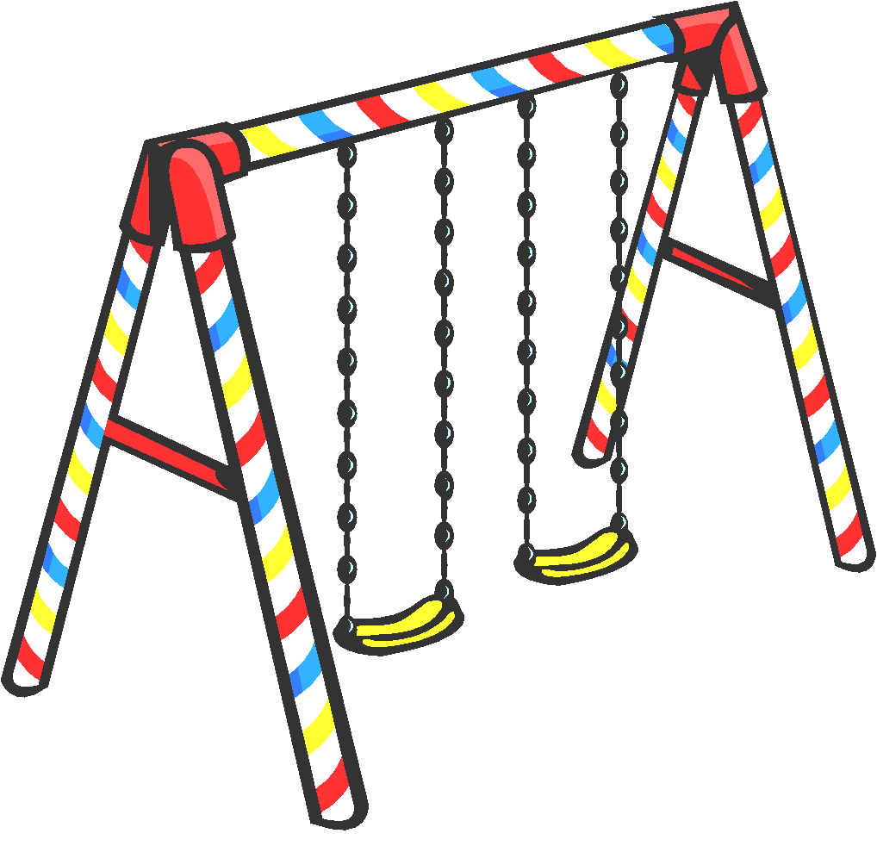
SUMMER 2026

Lynn Parks &
Recreation

Lynn Parks & Recreation
250 Commercial Street
Lynn, MA 01905

Office
Park Ranger’s Office
106 Pennybrook Rd
Lynn, MA

Summer Office Hours
Monday through Friday
8:00 AM to 4:00 PM

You can reach us by:
Phone: (781) 477-7123
Email: lynnparksandrecreation@gmail.com
2026 Lynn Parks & Recreation
Parks open Monday, July 6, 2024

The City of Lynn will provide Park Instructors to the parks listed below. The Park Program is available for children 6 years or older. No child is required to remain at the park. We DO NOT provide INDIVIDUAL SUPERVISION or DAYCARE.
On rainy days the Parks will be closed!

The following parks will be supervised:
Monday through Friday 9:00 AM -3:00 PM
From July 6th through August 7th

Barry Park (On Boston St. between Laurel and Cottage St.)
Clark Street Playground (Off Eastern Ave.)
Cook Street Playground (Between Allen and Rockway St.)
Gallagher Playground (Off of Ontario St.)
Gowdy Park (On Cedarbrook Rd. Between Tuscan Rd. And Maple Valley Rd.)
Lynn Woods Playground (At the end of Great Woods Rd. off Lynnfield St.)
Keaney Park (Behind Lynn English High School)
Kiley Playground (At the end of Sanderson Ave. off Chatham St.)
Warren Street Playground (Between Commercial St. and Huss Ct.)

LYNN PARKS & RECREATION
250 Commercial Street
Lynn, MA 01905
781-477-7123
Please Print Clearly:

Name of Playground______________________
Name of Child________________________________ Sex________
Age__________ Date of Birth__________________
Telephone #___________________
Address___________________ Zip Code___________
School____________________ Grade______________

In Case of Emergency, Please List Two People Who We Should Contact:

1. Name______________________ 2. Name _____________________
Relationship___________________ Relationship __________________
Address _____________________ Address _____________________
Phone 1 ______________________ Phone 1______________________
Phone 2______________________ Phone 2______________________
E-mail Address________________ E-mail Address________________

Does your child have any:
• Limitations • Illnesses • Allergies
If YES, please list & explain:________________________________________
______________________________________________________________

WE, OF THE LYNN PARKS & RECREATION PROGRAM, WILL TAKE ALL PRECAUTIONS AGAINST ANY CASUALTIES OCCURING WHILE THE CHILDREN ARE INVOLVED IN OUR ACTIVITIES. HOWEVER, WE ARE NOT FINANCIALLY OR LEGALLY RESPONSIBLE FOR ACCIDENTS THAT MAY HAPPEN WHILE THE CHILDREN ARE IN OUR PRESENCE. BEFORE YOUR CHILD MAY BE ENROLLED IN OUR SUMMER PROGRAM, YOU MUST UNDERSTAND OUR POSITION AND ACCEPT IT BY SIGNING BELOW.

Parent’s Signature:___________________________________Date:_______
LYNN PARKS AND RECREATION
EMERGENCY CARD INFORMATION

Child's Name: ___________________________ Date of Birth: ___/____/____

Child’s Home Address: ____________________________________________

Guardian’s Email: ____________________________________________

INSTRUCTIONS TO REACH PARENT/GUARDIAN
1.____________________________________________________________
Name Address Phone #
2.____________________________________________________________
Name Address Phone #

PEDIATRICIAN OR SOURCE OF HEALTH CARE
____________________________________________________________
Doctor’s name Address Phone #

EMERGENCY CONTACT PERSON(S)
1.____________________________________________________________
Name Address Phone #
2.____________________________________________________________
Name Address Phone #

MEDICAL EMERGENCY TREATMENT
I hereby give the Lynn Parks and Recreation permission to administer basic First Aid and/or CPR to my child________________________________________. And/or take my child to a hospital and to secure medical treatment when I cannot be reached or when delay would be dangerous to my child’s health.

Parent signature: _____________________________ Date: ___/____/____
Allergies, chronic health conditions:
______________________________________________________________

INSURANCE INFORMATION (OPTIONAL)
Company Name: ____________________________ Policy #: ________________
Participating Hospital: ______________________________________________
Special Instruction: ________________________________________________
PARENTAL CONSENT and RELEASE FORM LIABILITY
City of Lynn Parks and Recreation
2026 Summer Program
July 6th – August 7th

I/We, the undersigned parent(s) or guardian(s) of ____________________________, a minor, do hereby consent to his/her participation in the City of Lynn Parks and Recreation 2026 and Lynn Parks and Recreation Summer Field Trips.

I/We forever RELEASE, acquit, discharge and covenant to hold harmless the City of Lynn, a municipal corporation of the Commonwealth of Massachusetts, and its officers, employees, servants, and agents from any and all actions, causes of action, claims, demands, costs, loss of services, expenses and compensation on account of, or arising out of, directly or indirectly, any personal injuries or property damage which I/We may hereafter have as the parent(s) or guardian(s) of said minor, and also all claims or rights of actions for damages which said minor may acquire, either before or after he/she has reached his/her majority, resulting from his/her participation in the field trip herein described.

________________________________________________________________________
Signature of Parent(s) or Guardian(s) Date Relationship

PARENT/GUARDIAN Child Photo Release Form
Campers Name:_______________________________________ Grade:_____________
- I hereby grant permission for films, video and/or audio tape recordings, slides and photographs to be taken during the Lynn Parks Program, including field trips and other parks-related activities. I understand that this media will be produced and used for promotional purposes. I authorize the Lynn Parks and Recreation to use my photograph on its World Wide Web site, the parks’ social media sites, or in other official parks programs printed publications without further consideration, and I acknowledge the Lynn Parks and Recreation may choose not to use my photo at this time, but may do so at its own discretion at a later date.

I also understand that once my image is posted on the Lynn Parks and Recreation website, the image can be downloaded by any computer user. Therefore, I agree to indemnify and hold harmless from any claims the following:
- All employees of the Lynn Parks and Recreation Program
The Lynn Parks and Recreation reserves the right to discontinue use of photos without notice.
- You do not have my permission for films, video and/or audio tape recordings, slides and photographs to be taken for any reason.
This release will supersede any previous releases on file.
Parent/Guardian Name: (Please Print)____________________________________________
Signature___________________________________________________________________
Address:____________________________________________________________________
Phone:_____________________________________________________________________
Date:_______________________________________________________________________

LYNN PARKS AND RECREATION
TRANSPORTATION PLAN AND AUTHORIZATION
7.90(3) AND 7.12(1)

CHILD’S NAME: ______________________________________________________ PARK___________________________

MY CHILD WILL ARRIVE AT THE PROGRAM BY:

______ PARENT DROP OFF

______ OTHER (DESCRIBE _________________________________________________)

MY CHILD WILL DEPART FROM THE PROGRAM BY:

______ PARENT PICK-UP

______ OTHER (DESCRIBE __________________________________________________)

I give my child permission to be released from the program at the end of the day as stated above and/or I give my permission to the following people to receive my child at the end of the day.
(If no one is authorized, please indicate below by writing “NO ONE”)

Name _______________________________________ Relationship - _____________________
Address _____________________________________ Phone ( ) _____________________

Name _______________________________________ Relationship - _____________________
Address _____________________________________ Phone ( ) ______________________

Name _______________________________________ Relationship - _____________________
Address _____________________________________ Phone ( ) ______________________

ANY OTHER TRANSPORTATION REQUEST MUST BE STATED IN WRITING AND MAINTAINED IN THE CHILD’S FILE OR THE ABOVE PLAN MUST BE IMPLEMENTED.

THE PERMISSION IS VALID FOR ONE PROGRAM YEAR FROM THE DATE OF SIGNATURE.

PARENT/GUARDIAN SIGNATURE: ________________________________________
DATE: _____/______/________
2026 FIELD TRIP PERMISSION SLIP

Child’s Name: ___________________________________________________________________
Playground: _____________________________________________________________________
Parent/Guardian’s Name: _____________________________________________________
Parent/Guardian’s Phone Number: ___________________________________________
Emergency Contact Name: ___________________ Number: ______________________
Please check either “YES” or “NO” for each of the following field trips. Your child will only be able to attend the field trips next to which “YES” is checked off.

Payment is due the Friday before each field trip via lynnma.myrec.com

FIELD TRIP | DATE | YES | NO | Cost
Stone Zoo @ Stoneham  (Includes Zoo admission, transportation and lunch) | 7/14 |  |  | $32
Richardson’s and Mini Golf @ Middleton  (Includes a round of mini golf at Golf Country and one kiddie ice cream from Richardson’s, transportation and lunch) | 7/21 |  |  | $33
Salem Willows @ Salem  (includes 30 Game Tokens, 2 slices of cheese pizza and soda, and transportation) | 7/28 |  |  | $34
Lego Discovery Center @ Somerville  (Includes admission, transportation and lunch) | 8/4 |  |  | $36

I give my child, _______________________________, permission to attend the field trips to which I have indicated “YES.”

Parent/Guardian Signature: ___________________________________________
Date: ______ / ______ /______

